Midterm Paper Edu 3
12.What is the application level in cognitive domain? Explain with examples:3
Application level:
Again here are certain questions; you are going to identify common things in these questions:
• Classify the following materials in transparent, translucent and opaque objects.
• Classify the given foods into vegetables, fruits and meat group.
• Use the formula.
Breadth x Length = Area (to find out area of your geometry box).
Application level:
Words often found in application level questions:
- Apply
- Show
- Demonstrate
- Choose
30.Horizontal dimension of planning 2
Horizontal dimension of planning:
In horizontal level, planning includes selection of activities, resources, assessment and
homework
31.How can u develop social capital in students 3
It is the responsibility of a teacher to increase the social capital of every student.
Most of the times, teachers come to the class with lesson plan, teach the lesson to the
students. They expect from the students to listen to the lesson, they give them written
work and then leave. There is no time for the students to communicate with each other
except in break or after school. It is the responsibility of the teacher to increase the social
capital of students by organizing group activities. Instead of doing things alone, they may
communicate with each other. In this way, they will increase their thinking skills also
32.Educational goal 3
Goals: Statement of intent stated in broad term. Goal of a teacher is “A teacher is
responsible to produce good citizen.” Can we produce good citizens in 40 or 45 minutes
lecture? Definitely no. but daily class lecture of 45 minutes can make a long time to
achieve a goal.
33.What aspects possess teacher to be a professional 5
The students who are enrolled in 4 years B.Ed program have the curriculum. This
is basically a content which is based on all the concepts and principles to be learnt
e.g. they will learn about how students learn? Philosophy of education, methods
of teaching, educational research, assessment & evaluation etc. so all these
subjects will provide them the knowledge which is a core requirement to be a
teaching professional
34.Performance objectives 5
Three characteristics of performance objectives
1. Performance 2. Condition 3. Criterion measure
35.Components of advance graphic organizer 5
Advance graphic organizer has three major components or attributes.
- Advance organizer is a statement of those elements that the learner will be required to
master in a lesson. i.e. it may be a statement or word e.g. food, noun etc.
- Advance organizer presents ‘big picture’ to establish relationship between different
concepts.
- Advance organizer model is based upon deductive learning.
37.unit plan vs lesson plan
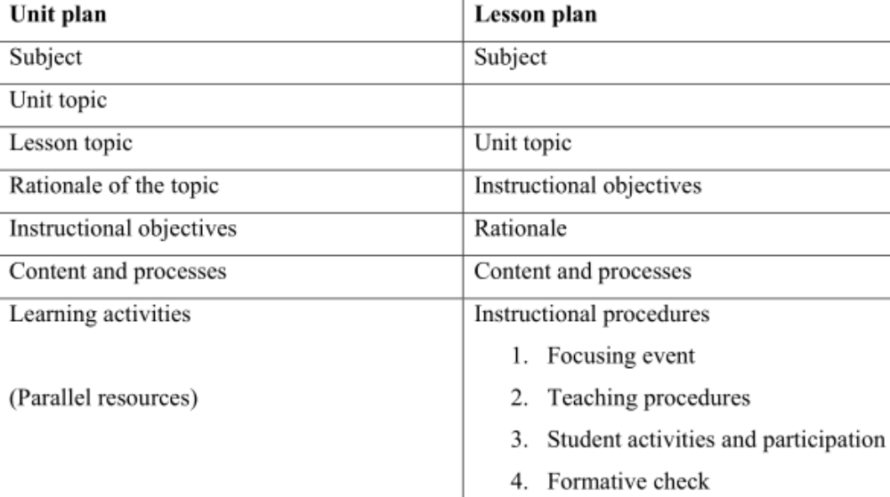
Q40: which competency is important for teacher in learning?
Content knowledge
41. Quality of a Good teacher
A good teacher is the, one who plans a lesson, implement it and evaluate it after implementation. A good teacher is the one who engages the students in active learning, a good teacher must know Assessment and Evaluation, Teaching techniques and skills, Pedagogical content knowledge,
.
43.Kinesthetic learning
Kinesthetic learning is that in which the student carrying out a physical activity, rather than listening to a lecture or watching a demonstration
44. How Growth and Self-respect are the factor of motivation
45.How apprentice ship model effective the teacher
It is based on Vygotsky’s work, which involves peers working closely together with a
teacher in joint problem solving. e.g. workshops and skill-learning centers.
47. Bloom’s taxonomy three strategies to revising the students ?
There are 6 levels of Bloom’s taxonomy of cognitive domain. Knowledge is the first level, then
comprehension, and then application. These three levels are categorized as lower level of
learning. The next three levels, i.e. analysis, synthesis and evaluation are categorized as the
higher level of learning
What is CAP? Explain them. / Bloom’s taxonomy Domain
CAP: Cognitive, Affective and Psychomotor. / Cognitive (Knowledge), affective (Attitude) and psychomotor (Skills)
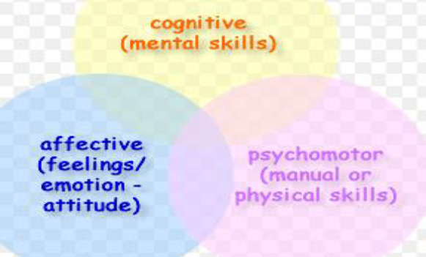
50.Requirements of lesson plan?
Subject, Instructional objectives, Rationale, Content and process, Instructional procedures
51.Benefits of unit plan
Unit planning is important because we need to know the reasons for dividing the whole thing into components. Most of the time teachers complaint for shortage of time. This problem can be solved by making the detailed unit plans. You can observe all the topics given in the yearly plan, and then identify the most important topics and the overlapping topics. You can omit the overlapping topics
whose level of difficulty is the same as taught previously. So, actually unit planning helps you to go through whole yearly plans
52.Why activities are important?
Activities are important because we do not teach processes to our students unless we do not include learning activities in our lessons
53.Presentation
Presentation is a teaching method where a teacher presents concepts and procedures
Why school is important for social development?
In social development very important things are sharing (like making friends), observes rules arrangements and physical developments, so for these all school plays important role.
55.zone of proximal development?
The gap between actual and potential level of a child is Zone of Proximal Development.
Vygotsky is very famous for this concept of his theory.
58.jean piaget date of birth... 2
Jean Piaget date of birth
9 august, 1896
59.what are the effects if not followed the sequence. in lesson plan. 5
62.Lesson plan 2 marks
Lesson is a piece of a unit NOT a block of time. If you have decided to teach a unit of
light to the students, definitely a whole unit of light cannot be taught in one lesson. You
need to divide the whole unit in certain pieces. May be you decide to divide the whole
unit of light into 10 pieces, so each piece would require a plan. That plan is called lesson
plan
63 Bloom taxonomy 2 mrks
Bloom taxonomy
There are 6 levels of Bloom’s taxonomy of cognitive domain. Knowledge, comprehension, application, analysis, synthesis and evaluation
64.Elaboraton method 3 marks
66.Curriculum planning purpose 5
Curriculum planning is done on the basis of needs of the society. There are three
foundations of curriculum: sociological, philosophical and psychological. So, your
societal needs are identified and on the basis of those needs curriculum is developed.
While in instructional planning, the needs are identified but these needs are of the
students. Firstly, the teachers identify students’ needs and then plan a lesson. Teacher
needs to differentiate a lesson in a way that he addresses pupil’s needs.
67.Inductive reasoning 5 mrks
Inductive Method:
Here the teacher does not tell the students that water is necessary for plants to grow. He directly
gives an experiment to the students; to put two plants in sunlight for 15 days, give water to one
of them and leave the other as it is in sun. Give a result after 15 days that what happen to the
plants. Now after experimenting, the students will give a conclusion that plants need water to
grow, if they give such conclusion then it is definitely an inductive mode of presentation.
Deductive and inductive are not only the modes of presentation but modes of experiments
also.
68.Reflevtive practice 5 mrks
Reflective practice
To explain reflective practice, I will first explain the light of reflection. The light of
reflection is “bouncing back of light to create an image.” Teaching reflection is related with the
light reflection for better understanding, the definition of teaching reflection or reflective practice
is:
“Answering some key questions to create an image of the classroom teaching and learning.” The
definition means that there are certain questions that teacher must answer by himself. He must
notice his classroom environment that if there are 30 students in a class, how much students are
answering the questions asked at the end of the lesson. How many students participate in
discussion? How many students participate in activities? These questions must be answered by
the teacher himself. The answers to these questions will actually tell the teacher that what the
environment of his class was. So, reflective practice is very important for a teacher. Being a
professional, I need to raise standard of my profession and reflective practice is definitely one of
the standards of teaching profession..
69.Do learner learn best alone?
Instead of doing things alone, they may
communicate with each other. In this way, they will increase their thinking skills also.
70. Evaluation instrument
We need evaluation instruments to assess students and teaching. Evaluation
instruments will always be developed when we have knowledge about these taxonomies.
E.g. if I want to evaluate the students in their sketching then I must know the taxonomies,
if I have decided to assess the students at mechanism level, then I must be having a
different check list to assess them. But if I want to assess them at origination level, then
my check list will be totally different. So if I do not know about the taxonomies, then I
will assess them as weather they have sketched something or not? Taxonomies are
important to learn because we will know the level of students learning.
72. Teacher serve as a social functionality
Teaching perceptions as culturally and socially embedded.
A survey was conducted for the clarification of this concept. In this survey, some teachers
were selected from rural and urban areas, and some from the private and government schools.
Then the ideas of the teachers and parents of the students were analyzed to see weather they
differ or not.
• Firstly, the teachers from urban schools say that it is their responsibility to teach
discipline to the students. The same was the perception of parents, they say that teachers
are very respectable and must teach students discipline and behaviors. And students must
obey them.
74. What is important model for curriculum planning?
Ans.Task analysis model is a very important model
7 5. What is the important thing that we use in Tyrol’s model and in Bloom’s Taxonomy?
The important thing in Tyler’s model and bloom’s taxonomy is that you observe the
Ultimate behaviors.
76. What is the application level in cognitive domain? Explain with examples:
Classify the following materials in transparent, translucent and opaque objects.
Classify the given foods into vegetables, fruits and meat group
Use the formula. Breadth x Length = Area
Use the knowledge in a new situation is application level. Example: Give five things to the students to identify these three kinds of objects. These are: Cellophane sheet, paper, table, book, and wall. Now, if the students are able to identify that what are opaque, transparent and translucent objects then they are acquiring application level
81. What are the instructional aims for lesson planning?
Student-oriented (Instructional aims are broad)
Which methods are used for effective teaching regarding with sequencing?
Teacher needs to start lesson with simple steps,
Use concrete examples,
Add complexity to the lesson,
Introduce abstractions. (Heart beat and B.P)
.
82. What is short term planning?
Lesson planning is a short term planning.
83. What is lesson planning?
Lesson is a piece of a unit NOT a block of time
“A lesson plan defines objective, plans materials, resources and activities are mobilized for the efficient attainment of the selected objectives; and finally, evaluation criteria is also identified.”
84. What is multi methodology? 2
Different types of mental functions occur in the left and right hemisphere. Our brain is composed of right and left hemisphere.
86.Metaphors and analogies
Metaphors and Analogies
There is an example of elaboration through metaphor. Teacher taught the concept of cell to
students and then ask them to find some metaphors. Below is the table on the left side there are
the parts of cell and on right side there are metaphors of football. Different groups gave their
different thoughts one group said that cell is like a football game. In the cell the central point is
nucleus which holds the whole activity. In football it is the referee who controls the game. Goal
keeper’s function is also like a cell wall. Mitochondria gives energy to cell. Sports drink also do
the same functions. Maybe the teacher have used the task analysis model but they asked the
students to elaborate. All the knowledge in working memory will become the part of long term
memory through elaboration.
Drawings
Drawings
Children read some text, one situation is that teacher may ask some questions at the end and we
can assess the understanding level of children. Second situation is that teacher may ask them to
show the pictorial demonstration of the text. It is adding on. Adding on must not be confusing.
Same theme can be represented differently.

Teaching is a process not object 3 mrks
Teaching is the process to use different objects and ideas

Modeling processes:
These are attention, retention, production and motivation.

.

What are the instructional aims for lesson planning?
Instructional aims: Student-oriented
Sequencing
The art of developing logical plan for instructional activities is called ‘sequencing’
What is important model for curriculum planning?
Lesson planning
Approaches for Problem Based Learning
- Modeling
- Guiding
- Fade out
Q: Reflection in and on actions
Reflection on action means that you have to answer some questions so that you may
know what the environment of your class was.
2. Reflection in action comes from experience. Once a teacher is in class, she/he needs to
reflect on all his/her actions. The reflection on every action at the same moment when the
action is being taken is reflection in action.

Q: Deductive vs Inductive
(General to Specific) (Specific to general)
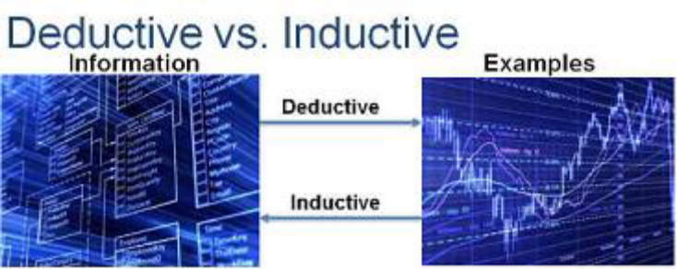
Q: instructional vs curriculum development
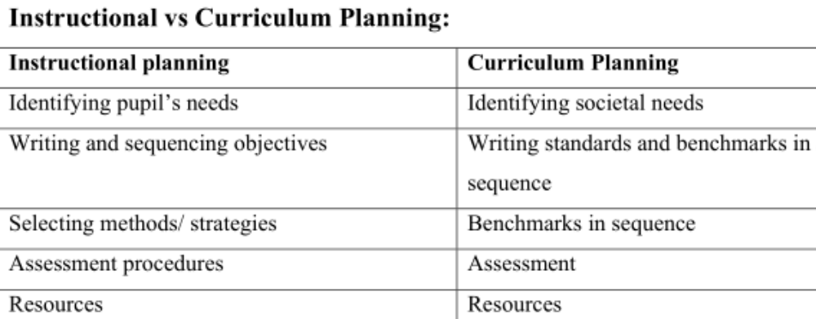

Q:Kinds of projects:
- Exploratory Projects
- Research Projects
- Product focused Projects
What is the application level in cognitive domain? Explain with examples:
use the knowledge in a new situation is application level. Now you give five things to the students to identify these three kinds of objects. These are: Cellophane sheet, paper, table, book, and wall. Now, if the students are able to identify that what are opaque, transparent and translucent objects then they are acquiring application level.

Production in modeling. 5
Production
Once you have paid attention to the model and retained the information, it is time
to actually perform the behavior you observed. Further practice of the learned behavior
leads to improvement and skill advancement.
Deductive method example 5
Deductive method:
Teacher tells the students that ‘Water is necessary for plants to grow’. Now the teacher asks
them to prove it. He gives them a task to put two plants in the sunlight. Give water daily to one
of the plants, and observe them after 15 days and tell which plant grows and which one is
withered. Now the students are proving that plants really need water to grow
History of reflective practice? 5
Ans. History of Reflective practice
Reflective practice I s a concept used in education studies and pedagogy. Reflective practice is a continuous process and involves the learner considering critical incidents in his or her life's experiences. Philosophers, theorists, educators and researchers have contributed to the development and growth of Reflective Practice. John Dewey (Dewey, 1933) is recognized as the eminent 20th century influence on reflection in education.
What is meant by condition? 2
ANS: Condition: Condition is a description of the conditions under which learner’s
Performance is to occur. They determine how, when, where and with what of
Performance.

